Sacajawea Fiber Arts Guild

Newsletter

Newsletter Editor: Teresa Breeden

September, 2023

Next Meeting: September 28
La Favorites, 204 S Pacific Avenue, Kelso
4:00 p.m. Social Time
4:30 p.m. Business Meeting
5:00 p.m. Program: Natural Dyeing presented
by Janet Heppler
5:30 p.m. Snacks
6:00 p.m. Show & Share



Program Notes

Guild member Janet Heppler will be speaking this month about methods for Natural Dyeing, covering the scouring of fiber, mordanting, dye baths, and the supplies needed.

At past guild meetings, Janet has brought some of her lovely hand dyed weavings, showcasing her natural dying talents.
She’ll tell us about collecting plant, fungi, and lichen material for dyeing, where certain plants and fungi can be found, and what time of year they are likely to be available in the forest.
Janet will share her collection of dyed wool and have some pictures of the plants and mushrooms that were used to create the colors. She has put together a couple of large notebooks, with pictures and samples, so we can see the results of her experiments.
It will be fun to see how she achieved those results!

Karin Finch

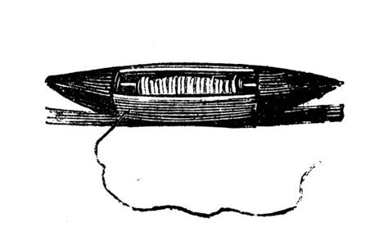

Just Shuttling Along

It seems like yesterday we were at the May 2023 Guild meeting feeling sad another year had come to an end. My goodness! My summer zipped by in a flash! Did yours? I can hardly believe we are about to gather for the beginning of another year of sharing our friendship and knowledge about the world of fiber arts. I am very excited to see everyone.

At our September meeting, Karin Finch, our Vice President, will let us know about the interesting calendar of programs she has scheduled. The fiber arts challenge for the year will be rolled out. It’s a fun idea that fits everyone’s niche so I’m hoping you will all be excited.

We’re also changing the flow of our meetings. We’ll be returning to hosting treats. If you are a newer member, we ask two people to sign up as hostesses to bring treats for the Social Time at 4:00 pm. Being a hostess isn’t mandatory, but it is a fun social activity we held prior to covid. Business Meeting will be at 4:30 pm. The big change is the Program will be at 5:00 pm. This will give non-member presenters the opportunity to share their expertise with us earlier. We will, of course, invite them to stay for the entire meeting, but some presenters have a distance to travel and may want to head out after the Program. Of course, Show & Share and Raffle will continue to be held – just immediately after the Program. I think the annual raffle item, which we draw for at the May meeting, is darling and something we can all use.

So, please mark your calendars for our September 28, 2023 meeting. See you then!
Marla

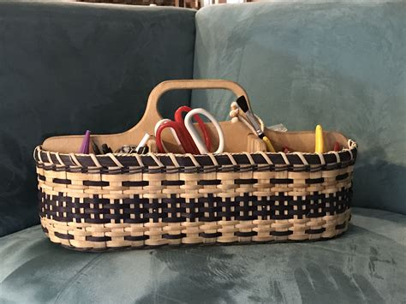

Minutes of May25, 2023

The meeting was called to order at 4:42 pm by the president. Eighteen members were present.
New member Heather Ederling was introduced.

Members adjourned for the annual potluck dinner.

The meeting resumed and the minutes of the April meeting were approved as distributed in the newletter.

Committee Reports
The treasurer, Ruth Laulainen, reported $2908.19 in the checking account, and $998.90 in the study grant account, with $40 added from the raffle.
Ardice Sauger-Stambuck was absent so there were no reports for membership or publicity.
The ANWG conference is next month, June, in Bend, OR.

Old Business
The silk scarf painting workshop is on Thursday, July 27 at LaFavorites. The cost is $45 which is due July 20th. Make checks out to Joan Hitchcock, and send the checks to Marla Imsland. Additional scarf blanks are $10-$15 depending upon the size.

Dues of $30 are due for the next year. Give or send them to Don Imsland.
The next meeting is the 4th Thursday of September, the 28th.

New Business
The new board members for next year are Marla Imsland, President; Karin Finch, Vice-President; Joy Winther, Secretary; and Don Imsland, Treasurer.

The chairpersons are as follows:
ANWG, Kathie Leigh Marts
Historian and Photographer, Matthew Moody
Librarian, Ardice Sauger-Stambuck
Membership, Samantha Loftin
Newsletter, Teresa Breeden
Properties, Kathie Leigh Marts
Publicity, Samantha Loftin
Raffles and Sales, Betty Englemann
Show and Share, Carol Bern
Study Grant, Robin Sparks
Technology, Jean Watson and Matthew Moody

Chairpersons are free to enlist help from other guild members when needed.

Old VCR tapes from the guild library were shown and the president read the titles. Kristen Buchanan moved and Teresa Breeden seconded that the tapes be digitized by Matthew Moody. The president gave the 6 tapes to Matthew to convert to a digital format.

The president encouraged members to sign up to demonstrate any fiber related skill at the summer fairs. The Kalama Fair is July 13-15 at Haydu Park. The Castle Rock Fair is July 13-15 also. There has been no response from the Cowlitz County Fair, held July 26-29. Kristen will get information on the Kalama and Cowlitz County Fairs regarding the guild’s participation. Members, when permitted, will attend 1 day with portable projects to demonstrate.

Marla and Don Imsland gave a report on their two week trip to Norway, including the town of Imsland, hometown of Don’s ancestors.

Announcements
Samantha Loftin suggested the possibility of guild members demonstrating fiber skills at the local Farmer’s Market at the end of summer in order to advertise and promote our guild.

Matthew Moody mentioned a craft group starting in Kalama. We could take guild brochures.

Carol Bern showed a book, The Indigo Girl, that she is willing to loan out.

Kristen Buchanan has about 15 raw fleeces that she will skirt and clean and give fleeces to someone who would want them. Marta volunteered to help. Other guild members are welcome.

The meeting adjourned at 6 pm.

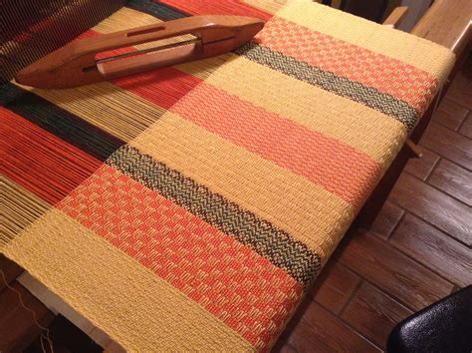

New Books Donated by the Portland
Guild

Step-by-Step Macrame’
By: Mary Walker Phillips

Color & Design in Macrame’
By: Virginia I. Harvey

Creative Body Coverings
By: Jean Ray Laury & Joyce Aiken

Contemporary Lace Making
By: Constance Nieuwlaoff

Encyclopedia of 300 Crochet Patterns Stitches & Designs
By: Doris M. Smith

Patchwork & Applique
By: Exeter Books

Jewelry with a Hook
By: Terry Taylor

New Directions in Chenille
By: Nannette Holmberg

Cross Stitch & Bead Weaving Magazine A Silk Ribbon Album
By: Jenifer Buechel

Funk & Wagnalls Adventures in stitches By: Mariska Karasz

Off-the-Shelf Fabric Painting
By: Sue Beevers

Knitting with Wire’
By: Nancie M. Wiseman

American Heirloom Bargello
By: Millie Hines

A Bearer of Tradition
By: Dwight Stump,Basketmaker

Encyclopedia of Ribbon Embroidery Borders
By: Rita Weiss

Patchwork & Applique
By: Pauline Chatterton

Knitting Little Luxuries
By: Louisa Harding

New Designs in Lace Making
By: Kristina Malmberg / Naime Thorlin

Beyond Craft the Art Fabric
By: Mildred Constantine/Jack Lenor Larson

Photos From the Castle Rock Fair

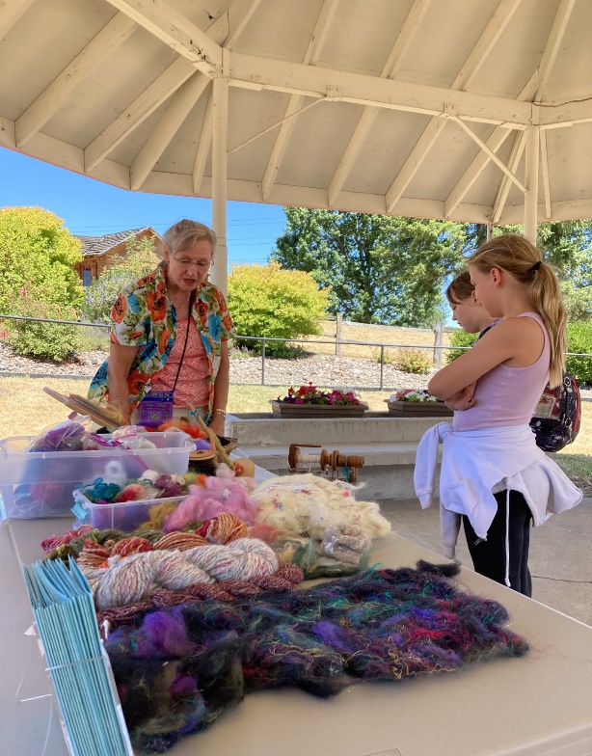

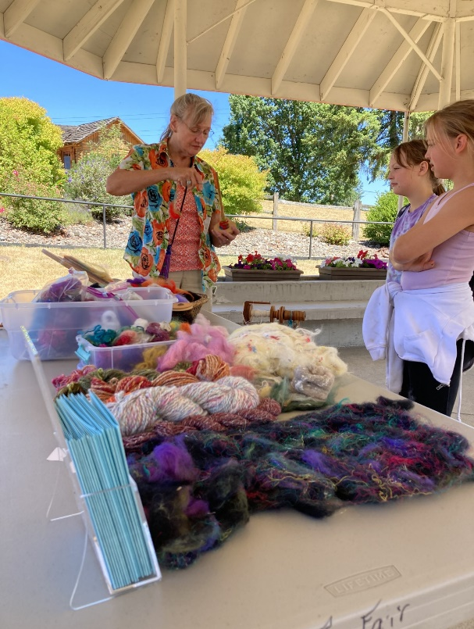

Photos from the Cowlitz County
Fair

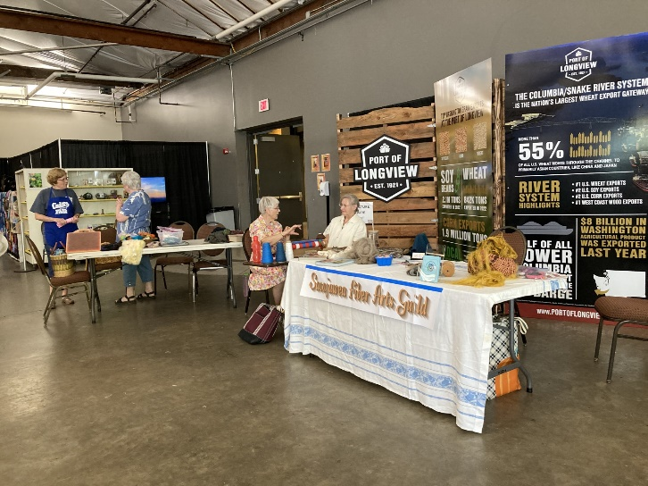

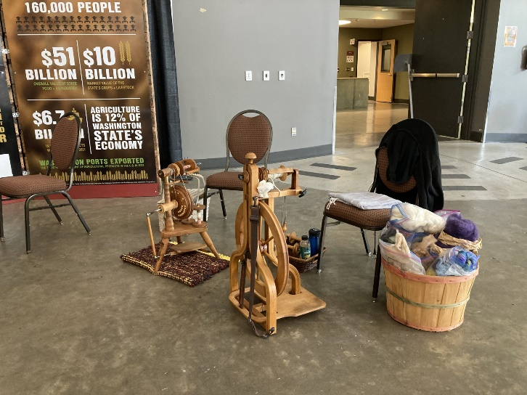

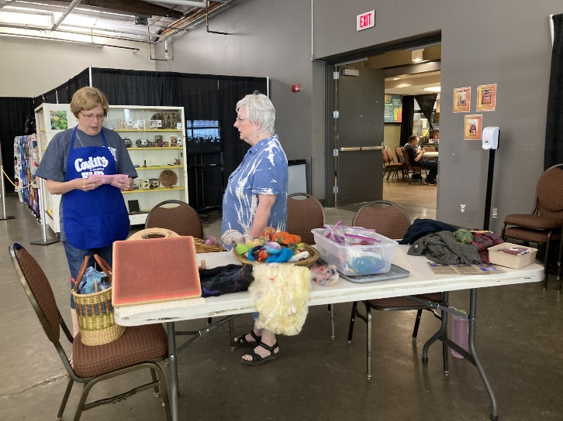

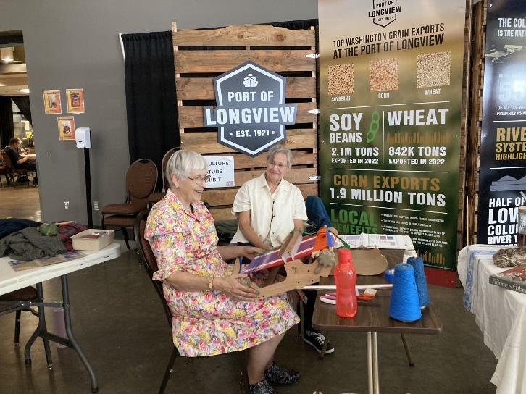

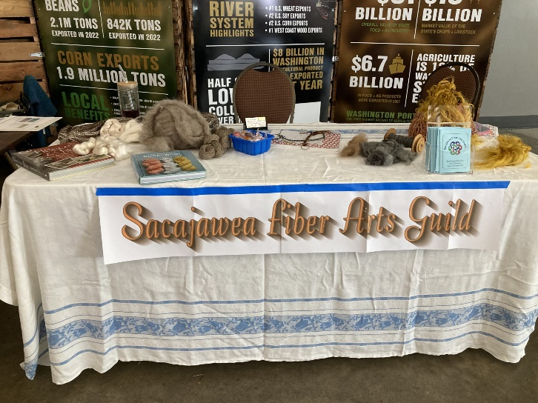

For Sale

Like New 16” 8-Shaft Ashford Table Loom
(includes Suitcase for storage)
$750

The perfect workshop loom. Easy to setup, easy to transport, easy to carry.

Contact Joy, 360-232-1116, for more information

For Sale
7 foot Adjustable Triangle Loom
$125 (No easel)

7-foot ADJUSTABLE TRIANGLE Shawl/Blanket FRAME LOOM

THE SMARTLOOM
The ONLY Loom that DRESSES ITSELF!!
Contact Joy, 360-232-1116, for more information

